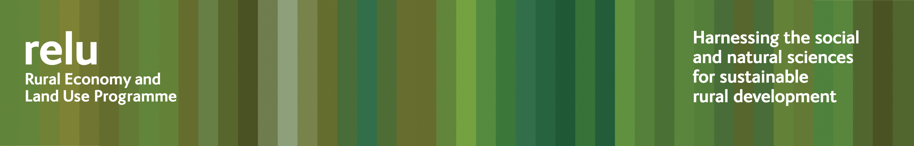
PRESS RELEASE for immediate release
3 June 2009
Is rural land use too important to be left to farmers?

As demands on rural land increase and we are all having to deal with the effects of climate change, we may need to take a fresh look at our priorities, according to leading academics at The Future of Rural Land Use, a conference organised by the UK Research Councils’ Rural Economy and Land Use Programme.

The conference is being held tomorrow, Thursday 4 June 2009, at Congress House, Great Russell Street, London. Members of the press are invited to attend.

Director of the Relu Programme, Professor Philip Lowe, said: “Our approach to the countryside in the UK has swung from a post World War 2 outlook of relentless expansion of food production, to surpluses in the 1970s and 80s, which gave us the opportunity for an unprecedented focus on conservation.

“But now we are once again experiencing anxieties about food security and a possible global food crisis. And this time we have climate change in the picture bringing additional demands on land. We need space for growing new biofuel crops and for water storage that could save more populated areas from flooding, we may need additional room for mobile or flexible infrastructure during extreme weather events, and yet at the same time more people than ever want to live in rural areas or to use the countryside for leisure pursuits, whether that means angling, shooting, walking, bird watching or horse riding.”

Relu researchers are coming up with some of the evidence that the government will need to make decisions about these kinds of priorities:

- Dr Angela Karp, who heads the Centre for Bioenergy and Climate Change at Rothamsted Research, is investigating the environmental impacts of growing the biofuels short rotation coppice willow and Miscanthus grass. Dr Karp said: ““The first generation of biofuels came in for a lot of criticism because they were seen as taking land away from food production. This second generation of crops could have much greater advantages. They are fast-growing, with the potential to produce large biomass yields on more marginal land from low inputs of fertilisers and pesticides. Although there are concerns that they are bad for biodiversity, our results revealed beneficial effects on plants, insects and birds for willow in particular.”
- Professor Joe Morris of Cranfield University is investigating more effective management of floodplains. He has found that there is considerable potential for using rural land for flood storage but other interests, including biodiversity may suffer. Professor Morris said: “There are conflicts, and trade-offs will increasingly have to be made. For example, flood management may not always sit comfortably with farmers’ commercial objectives. And should the interests of rural populations always be a lower priority than saving urban infrastructure?”
- Professor Bill Sutherland of Cambridge University is investigating how the management decisions that farmers take affects the biodiversity of their land. Professor Sutherland said: “Agricultural policy and economic conditions affect farmers’ livelihoods and their management decisions. Areas of land that were designated as set aside in the 1980s and 1990s are now being brought back into cultivation and this has implications for biodiversity. Our project is modelling the effects of this change and which species will be winners and losers.”

Research from the Relu Programme will be important for the complex policy decisions about land use that need to be taken at national and regional level.

Professor Philip Lowe said: “As we come to expect more and more from land, we have to decide what our priorities for land use are in the UK. We are well used to operating within a land use planning system in urban areas. Any system to be applied to rural land use would have to be much more flexible. There would undoubtedly be opposition from some land owners but we know that land will be a major asset for society in mitigating and adapting to climate change. Is it not time, at least for a wider public debate on this issue?”

Notes for editors:

- The Future of Rural Land Use is being held from 10.00 to 17.30 hrs on Thursday 4 June at Congress House. A programme may be found at http://www.relu.ac.uk/events/Conf%20June%202009/11064%20RELU%20A5%20Conf%20Invite%20Amended.pdf

- The Rural Economy and Land Use Programme is an interdisciplinary collaboration between the Economic and Social Research Council (ESRC), the Biotechnology and Biological Sciences Research Council (BBSRC) and the Natural Environment Research Council (NERC), with additional funding provided by the Scottish Government and the Department for Environment, Food and Rural Affairs. See www.relu.ac.uk for more information about the Relu programme.

- For any further information contact Anne Liddon, Science Communications Manager, tel 0191 222 6903, email relu@ncl.ac.uk.

ends

